

**RECIPE ORGANIZED SYSTEM**

**Software Requirement Specification**

– HoChiMinh, May 2023 –

**Table of Contents**

I. Overview 3

1. Introduction 3

2. System Functions 4

3. Common Requirements 5

II. Functional Requirements 6

1. <<Feature Name 1>> 6

a. <<Function Name 1>> 6

b. <<Function Name 2>> 6

2. <<Feature Name 2>> 6

# I. Overview

## 1. Introduction

Welcome to our web Cooking Recipe Organizer, a powerful tool designed to solve the problems many families face when it comes to locating culinary recipes that suit their hobbies or eating habits. We understand that meal planning and preparation can be a daunting task, and that's where our recipe organizer comes to your rescue.

Our recipe organizer provides a centralized platform for storing and organizing all your favorite recipes, making meal planning and preparation a breeze. With an array of features and functionalities, we aim to save you time and reduce the stress associated with creating delicious and healthy meals.

One of the key features of our recipe organizer is the robust search and filtering capability. Say goodbye to sifting through countless cookbooks or searching aimlessly online. Our intelligent search system allows you to find recipes based on specific ingredients, cooking time, cuisine type, or any other criteria you desire. Whether you're looking for a quick weeknight dinner or a special occasion dish, our organizer will help you discover the perfect recipe in no time.

Meal planning is made effortless with our recipe organizer. Simply select recipes from your collection, and our organizer will generate a cohesive meal plan ensure you have all the ingredients you need for each meal.

Sharing your favorite recipes with friends and family has never been easier. Our recipe organizer allows you to share recipes via social media, ensuring that your loved ones can enjoy the same delicious dishes that you do. You can also explore recipes shared by other users, expanding your culinary repertoire and finding inspiration from a vibrant community of food enthusiasts.

We understand the importance of maintaining a healthy and balanced diet. Our recipe organizer provides access to nutritional information for each recipe, allowing you to make informed choices that align with your dietary needs and goals. You can easily filter recipes based on specific dietary preferences, such as vegetarian, gluten-free, low-carb, or any other requirements you may have. Taking care of your health has never been more convenient.

In conclusion, our web Cooking Recipe Organizer is here to simplify your meal planning and preparation, helping you enjoy great-tasting and healthy meals without the stress. With its search and filtering capabilities, meal planning features, recipe sharing options, and dietary filters, our organizer is your ultimate companion in the kitchen. Get ready to embark on a culinary adventure, explore new flavors, and create memorable dining experiences with ease. Start using our recipe organizer today and unleash your inner chef!

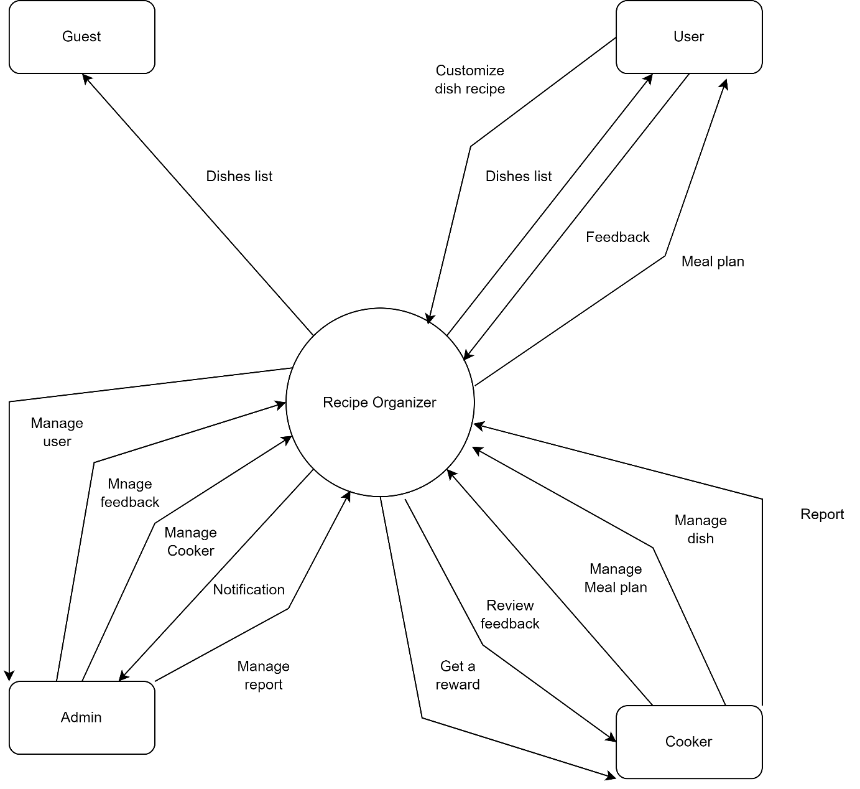

## 2. System Functions

#### a. Screen Flow:

#### Screen flow for User:

**Screen flow for Cooker:**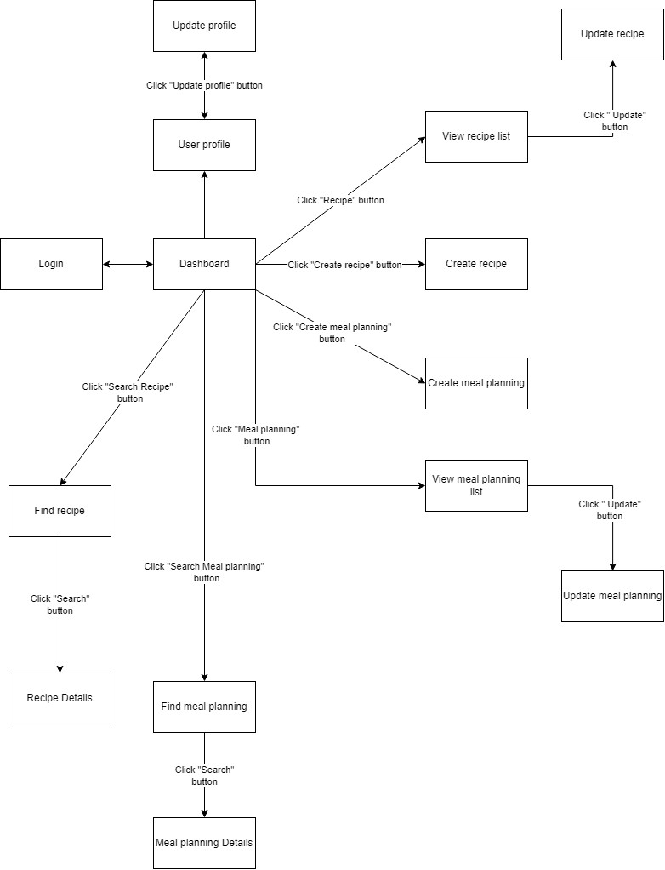

**Screen flow for Admin:**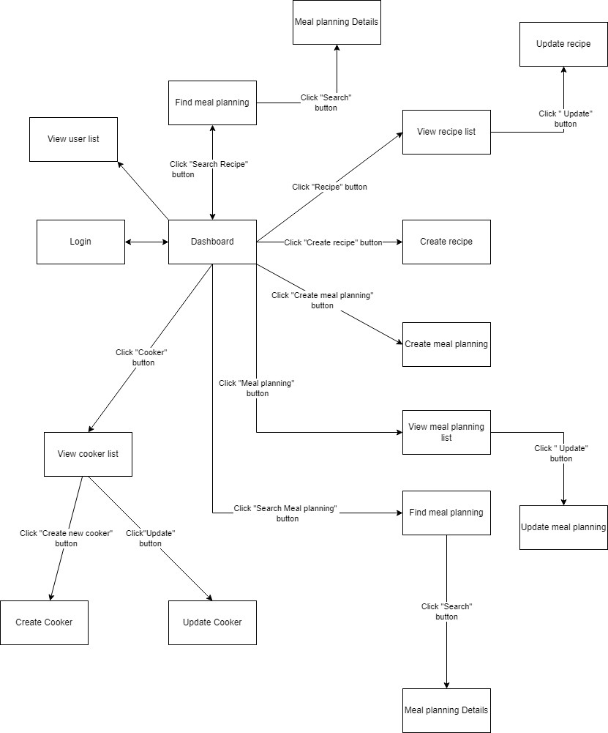

**Screen flow for Guest:**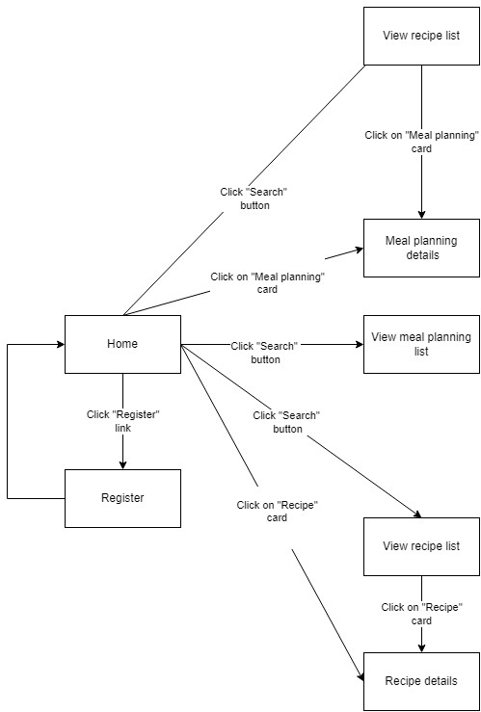

#### b. System Functions Details

|  |  |  |  |
| --- | --- | --- | --- |
| **#** | **Feature** | **Screen** | **Description** |
| 1 | Login with Account | Login | User input username(email) and password to login |
| 2 | Register Account | Create user | User insert informations to register |
| 3 | Edit Account | Update account information | Change private information |
| 4 | View lists of dishes | Homepage | Guest and users view all of dishes |
| 5 | View private informations | View informations | User can see private information |
| 6 | Search dish name | Search | Search by dish name |
| 7 | Search cooker | Search | Search by cooker name |
| 8 | Search ingredient | Search | Search by ingredient name |
| 9 | View details of dish | View | View all informations of the dish |
| 10 | Customize recipe | Create customize | Custom recipes |
| 11 | Edit Customize recipe | Edit | Edit customize recipes |
| 12 | Delete Customizing recipe | Delete | Delete customize recipes |
| 13 | Create feedback by user | Feedback | User can feedback about recipes |
| 14 | View feedback | Feedback | User can view again about recipes feedback |
| 15 | Save favorite recipe | Favorite | User can favotite recipes |
| 16 | Delete favorite recipe | Favorite | User can delete favorite recipes |
| 17 | View favorite lists | Favorite | View all of favorite dishes |
| 18 | Share recipe | Share | User can copy link to share |
| 19 | Sign up Cooker | Create cooker | Cooker can sign up with their CV |
| 20 | Create dishes | Create | Cooker crate new recipes |
| 21 | View lists of dishes which this cooker created | View | Cooker can view again list of dishes which cooker created |
| 22 | Edit cooker's recipe | Edit | Cooker can edit their recipes |
| 23 | Manage meal planning | meal planning | Cooker can manage meal planing |
| 24 | Deactivate-activate account | Update status | Admin can deactivate-activate account |
| 25 | Create cooker account | Create cooker | Admin can create cooker when cooker sign up |
| 26 | View log | View history | Admin can view history of user and cooker |
| 27 | Create Dashboard page | Dashboard | Admin can praise cooker bases on Dashboard page |
| 28 | Report cooker | Report | User can report cooker |
| 29 | Confirm report with algorithm | Report | Confirm report by system |
| 30 | Confirm report by admin | Report | Admin can confirm report |
| 31 | Complain if reported | Review authentication | Cooker can complain if reported |
| 32 | Notification to admin | Review authentication | Notificate to admin when cooker sign up |
| 33 | Show rating | Promote, Demote user | User can rate recipes |
| 34 | Caculate avarage rates | Promote, Demote user | System caculate average rates |
| 35 | Reward | Promote, Demote user | System can reward when cooker have 10 post |
| 36 | Update Avatar | Edit profile | User can update avatar |

#### c. User Authorization

|  |  |  |  |  |  |
| --- | --- | --- | --- | --- | --- |
| **Screen** | **Guest** | **Customer** | **Sub-Admin** | **Admin** | **Bought Recipes** |
| <<Screen Login>> | x | x | x | x | x |
| Login Account | x | x | x | x | x |
| Register | x | x | x | x | x |
|  |  |  |  |  |  |
| <<Screen Main>> | x | x | x | x | x |
| Search Recipes | x | x | x | x | x |
| Query Category List | x | x | x | x | x |
| Query Best Recipes | x | x | x | x | x |
| Query New Recipes | x | x | x | x | x |
| Recipes Page Information | x | x | x | x | x |
|  |  |  |  |  |  |
| <<Screen Recipes Information>> | x | x | x | x | x |
| View Recipes Information | x | x | x | x | x |
| Add Recipes To favorite |  | x | x | x | x |
| Review Recipes |  | x | x | x | x |
|  |  |  |  |  |  |
| <<Screen Favorite>> |  | x | x | x | x |
| List Recipes |  | x | x | x | x |
| Delete Recipes |  | x | x | x | x |
| Adjust Ingredient Quantity |  | x | x | x | x |
| Update Ingredient For Recipes |  | x | x | x | x |
|  |  |  |  |  |  |
| <<Screen Upload New Recipes>> |  | x | x | x | x |
| Upload Image |  | x | x | x | x |
| Upload Category |  | x | x | x | x |
| Upload Recipe Name |  | x | x | x | x |
| Upload ingredient |  | x | x | x | x |
| Insert Recipe Detail |  | x | x | x | x |
| Upload Cooker Information |  | x | x | x | x |
| Preview Recipe Detail |  | x | x | x | x |
|  |  |  |  |  |  |
| <<Screen User Information>> |  | x | x | x | x |
| Insert User Information |  | x | x | x | x |
| Insert Update Information |  | x | x | x | x |
| Query User Information |  | x | x | x | x |
|  |  |  |  |  |  |
| <<Screen Review Product>> |  |  |  |  |  |
| Insert Review Recipe |  |  |  |  |  |
|  |  |  |  |  |  |
| <<Screen Admin>> |  |  |  | x |  |
| Search User |  |  |  | x |  |
| Query User List |  |  |  | x |  |
| Demote Sub Admin |  |  |  | x |  |
| Promote User to Sub Admin |  |  |  | x |  |
| Confirm New Recipes |  |  |  | x |  |
| Confirm Review |  |  |  | x |  |
| Confirm Update Recipes Information |  |  |  | x |  |
| Query All Recipes |  |  |  | x |  |
| Delete Recipes |  |  |  | x |  |
| Confirm Delete Recipes |  |  |  | x |  |
|  |  |  |  |  |  |
| <<Screen Sub Admin>> |  |  | x | x |  |
| Confirm New Recipes |  |  | x | x |  |
| Confirm Review |  |  | x | x |  |
| Confirm Update Recipes Information |  |  | x | x |  |
| Query All Recipes |  |  | x | x |  |
| Delete Recipes |  |  | x | x |  |
| Confirm Delete Recipes |  |  | x | x |  |
|  |  |  |  |  |  |

## 

## 

## 

## 3. Common Requirements

* Create an online web for FAMILY customers, cooks and admin.
* Main page should have top rating Recipes and new Recipes.
* Dishes on the main page should show recipe and chef details.
* Customers must login by email.
* Customers can register for an account .
* Customers can view personal information on their personal page after login.
* Customers can search Recipes.
* Customers can choose Recipes to add in their favourite page.
* Customers should be able to cancel their Recipes from their favourite page.
* The favourites page will display wish lists added by the customer..
* Customers can update their information.
* Customers can rate Recipes .
* Customers can share Recipes by.
* Customers should be able to create their own meal planning .
* Customers should be able to update their meal planning information.
* The Cook must register by sending a profile to admin.
* The Cook must login with the email provided by the admin.
* The Cook can create new Recipes for customers.
* The Cook can create new meal planning.
* The Cook can update their information.
* The Cook can check Recipes review score.
* Admin must approve Recipes.
* Admin must approve reviews for the Recipes.
* Admin can check notifications from customers and chefs
* Admin can check login logs from customers and chefs
* Admin can promote and demote user roles or cooks.
* Admin can create reward event for customer and chef.